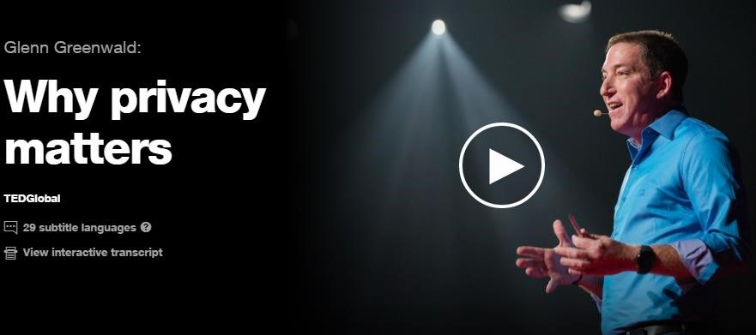

|  |  |  |  |
| --- | --- | --- | --- |
| **Helpful vocabulary:** | |  |  |
| devoted entails humiliation crux revelations unbeknownst  unprecedented plot  self-deprecation safeguard private realm cease infamous issue desolate place voluntarily judgmental mortified claim vastly devised inmates | gewidmet  schliesst ein  Demütigung  Krux, harter Kern Enthüllungen unbekannt beispiellos im Geheimen planen Selbstherabwürdigung  schützen Privatsphäre unterlassen berüchtigt Thema  trostloser, leerer Ort freiwillig  wertend, beurteilend gedemütigt behaupten erheblich entwickelte, erdachte  Häftlinge | crucial obedience compliance mindset means subtle fostering orthodoxy misapprehension  narrator assumption scrutinized omniscience breed craves dissent reside entrenches insidious bargain render yourself wield | ausschlaggebend Gehorsam  Übereinstimmung  Denkweise, Mentalität  Mittel  raffiniert, subtil fördern, aufziehen Rechtgläubigkeit falsche Auffassung  Erzähler  Annahme  gründlich untersucht Allwissenheit züchten, hervorbringen  begehrt  Dissens, abweichende Meinung  Platz haben etabliert, verankert hinterhältig, heimtückisch Übereinkunft, Deal sich ergeben ausüben |

1. **According to the 20th-century French philosopher Michel Foucault, what does mass surveillance create?**

*If you do not know if you are being watched but might be then you will always behave as if you are.*

1. **What is the mindset Glenn Greenwald bases his entire speech on?**

*If you have nothing to hide why would you care about being watched?*

1. **Does he support or oppose this mindset?**

*He opposes it*

1. **According to Glenn Greenwald, which two destructive messages does this mindset entrench?**
2. *The only people who seek privacy are criminals and people who have something to hide.*
3. *Only if you are willing to render yourself harmless to the people in power you are free from the consequents of mass surveillance.*
4. **According to Glenn Greenwald, what is the measure of how free a society is?**

*Not how it treats the ones that behave the system but the ones who oppose it.*

1. **What does Greenwald say about the effects of a system of mass surveillance?**

*It makes people act less free because they always assume, they are being watched*

**"I don't really worry about invasions of privacy because I don't have anything to hide."**

Personally, I can say, that I have certain things which I do not share to others. I think there are many things that are very personally about me and It would be burden me hard if someone would know that without telling it to this person. I do protect myself against that with methods like not posting data about me into the internet (Instagram etc.). The internet never forgets. This is for some people a real problem. Many people do not care about and post and share things about themself without thinking about the fact that the internet does not forget. I think it is more important to care about personal data then ever before.